Table of Contents

**Janmashtami: The Divine Birth of Lord Krishna** 2

Introduction: Celebrating the Avatar of Love and Wisdom 2

Mythological Significance of Janmashtami 3

The Birth of Krishna 3

Traditional Celebrations and Rituals 3

Fasting and Midnight Celebrations 3

Bhajans, Kirtans, and Dance-Drama 3

Jhulan Utsav (Swing Festival) 3

Unique Celebrations: Dahi Handi 3

Regional Variations Across India 4

Spiritual and Philosophical Essence 4

Conclusion: The Eternal Presence of Krishna 4

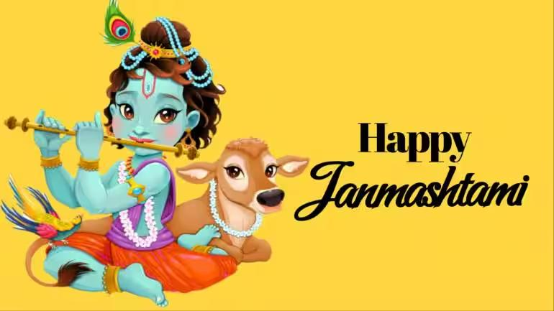

# **Janmashtami: The Divine Birth of Lord Krishna**

## Introduction: Celebrating the Avatar of Love and Wisdom

**Janmashtami** is one of the most sacred and widely celebrated Hindu festivals, commemorating the **birth of Lord Krishna**, the eighth avatar of Lord Vishnu. It is observed on the **eighth day (Ashtami) of the dark fortnight (Krishna Paksha)** in the Hindu month of **Bhadrapada** (August–September). Celebrated with **devotion, fasting, dance, and drama**, Janmashtami honors Krishna as the divine protector, philosopher, and friend — whose teachings in the **Bhagavad Gita** continue to inspire generations.

## 

## Mythological Significance of Janmashtami

### The Birth of Krishna

Lord Krishna was born in **Mathura**, in a prison cell, to **Devaki and Vasudeva** during a time of tyranny under King **Kansa**, Devaki’s evil brother. It was foretold that Devaki’s eighth son would destroy Kansa. To protect Krishna, Vasudeva secretly carried the infant across the **Yamuna River** to **Gokul**, where he was raised by **Nanda and Yashoda**.

Krishna’s life is seen as a divine **manifestation of love, playfulness, and cosmic wisdom**, from his childhood antics to his role in the **Mahabharata**.

## Traditional Celebrations and Rituals

### Fasting and Midnight Celebrations

Devotees observe a **strict fast (upavasa)**, which is broken only after midnight — the believed hour of Krishna’s birth. Temples are decorated with flowers and lights, and the deity is bathed, dressed, and placed in a cradle.

### Bhajans, Kirtans, and Dance-Drama

All-night **bhajan (devotional singing)** sessions, **kirtans**, and performances of **Raslila** (dramas depicting Krishna's life) are central to the celebration. These reenact Krishna’s childhood mischief, miracles, and divine love stories with Radha and the gopis.

### Jhulan Utsav (Swing Festival)

Beautiful swings decorated with flowers are set up for baby Krishna idols, and devotees gently sway the cradle as a symbolic gesture of care and joy.

## Unique Celebrations: Dahi Handi

In Maharashtra and parts of Gujarat, Janmashtami is celebrated with the thrilling event called **Dahi Handi**. Inspired by Krishna's love for butter and curd, teams called **Govindas** form human pyramids to break a clay pot (handi) filled with curd, tied high above the ground. The event draws huge crowds and symbolizes **teamwork, courage, and devotion**.

## Regional Variations Across India

* **Mathura and Vrindavan**: These towns host **grand Raslilas**, temple processions, and elaborate decorations, as they are directly associated with Krishna’s childhood.
* **Dwarka (Gujarat)**: As Krishna's later kingdom, Dwarka holds massive religious gatherings and prayers.
* **Manipur and Assam**: Celebrated with traditional Manipuri dance and Vaishnavite rituals.
* **South India**: In Tamil Nadu and Kerala, homes are decorated with **tiny footprints** symbolizing baby Krishna’s arrival.

## Spiritual and Philosophical Essence

Janmashtami is not just a celebration of birth — it is a reminder of Krishna’s divine message:

* **Dharma (righteousness) over adharma (evil)**
* **Detachment and duty without expectation**
* **Compassion and joy in all actions**

Through the **Bhagavad Gita**, Krishna teaches the world about **karma, devotion (bhakti), and self-realization**, making Janmashtami a time for **both joyous celebration and inner reflection**.

## Conclusion: The Eternal Presence of Krishna

Janmashtami is a celebration of **hope, devotion, and the eternal triumph of good over evil**. It brings together spiritual seekers, families, and communities in honoring **Krishna’s divine play (leela)** and teachings. Whether through fasting, singing, or festive games, Janmashtami allows people of all ages to **connect with the spirit of joy, love, and dharma** that Krishna represents.

In remembering his birth, we are reminded that the divine is always present — **within us and around us**, guiding us toward light, truth, and harmony.